Stuff to Submit
3) Lolucaslee/Lab_INF1103: Lab_INF1103
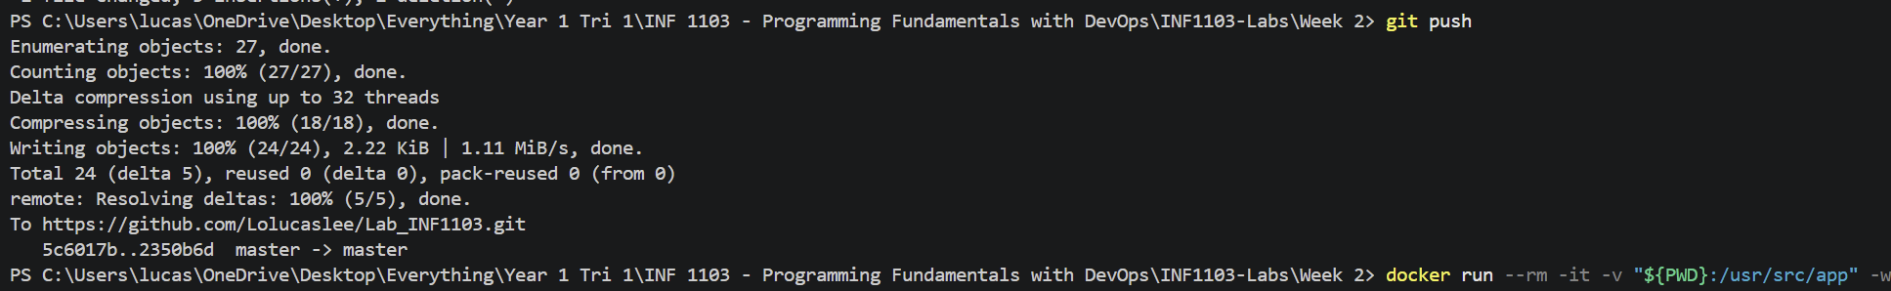
4)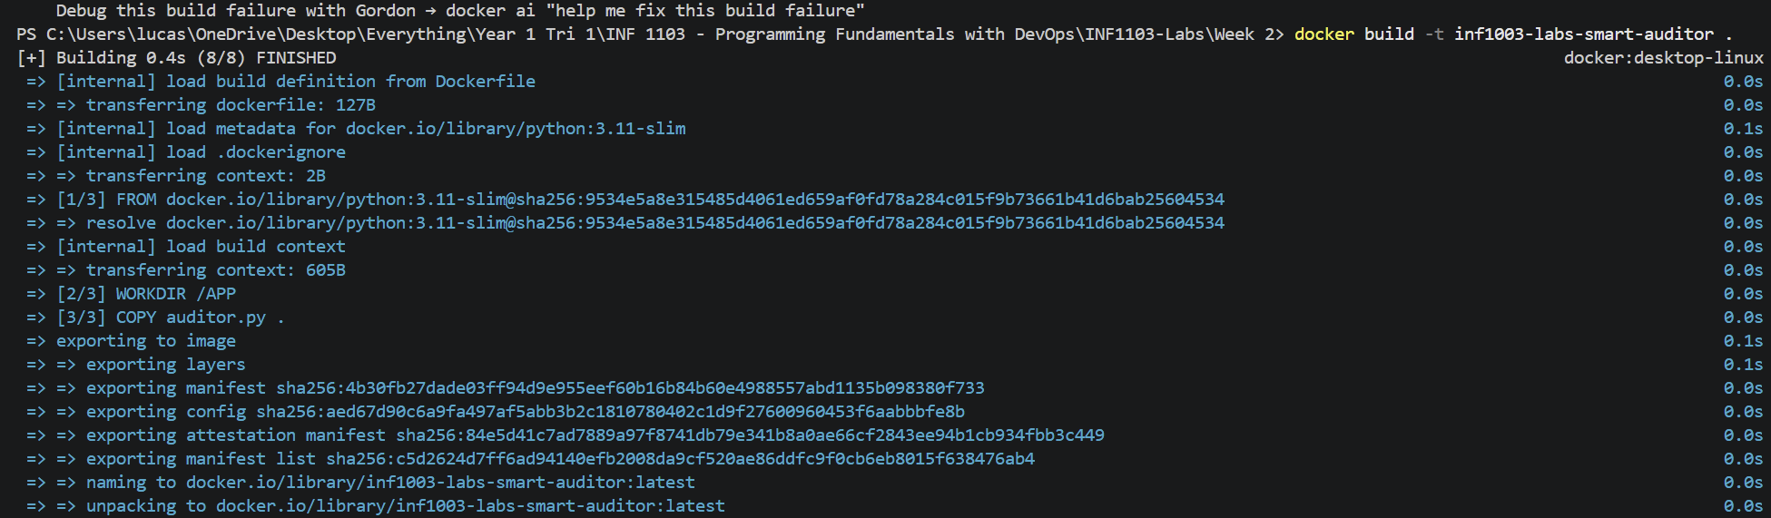
5)
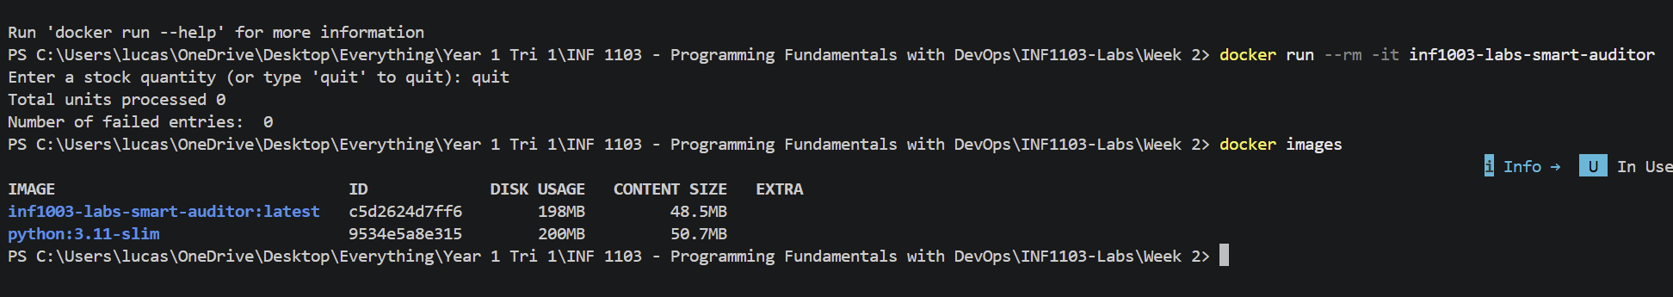
6)
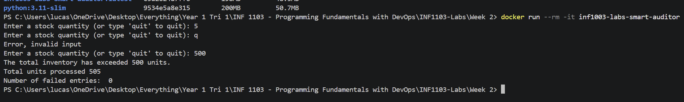

7) Self-Reflection
Once your auditor is working, consider this:
"If I want to save the final inventory count to a file so it doesn't vanish when the container stops, what fundamental limitation of Docker are we hitting?"
The fundamental limitation of Docker is its ephemeral (temporary) storage, which casus any data created or modified inside being lost when the container is stop or deleted.
To be able to store data, means that data has to be stored outside the container, by using Docker Volumnes, which is a standard managed storage locations on the host system. This survive container deletion and can be shared between containers.

